Tax Filing and Reconciliation: Shared Policy Allocation
Disclaimer: Shared policy allocation concerns have been reported to be affecting the tax filing and reconciliation process of consumers for the coverage year 2015. This is a new area of concern for assisters, tax preparers and the consumers. This fact sheet provides an overview of shared policy allocation and some general information for assisters and tax preparers to use as they work with consumers with shared Marketplace policies.
Shared Policy Allocation applies to all individuals and families who received premium tax credits as part of a household for any amount of time in a given coverage year, but are filing taxes separately because of family circumstances (e.g. marriage, married filing separately, divorce, income change that qualifies for filing separately, etc.). Some examples when this may occur include:
- A consumer legally divorced his or her spouse in 2015. The policy covered both spouses for all or part of 2015.
- A consumer was covered under his or her parent’s Marketplace policy for January-March 2015. The person got married and received coverage through their new spouse’s job. The consumer plans to jointly file taxes with his or her new spouse.
- A consumer was covered under his or her parent’s Marketplace policy for 2015. The consumer’s income increased during the year and he or she decided to purchase an individual policy through the Marketplace beginning in July of 2015.
Form 8962
If a consumer is dividing policy amounts with another tax payer, check “Yes” on Part II line 9 of the Form 8962.
The allocation percentages are reported on Part IV Lines 30-33 of the form 8962.
- The policy number of the shared health insurance plan is reported in section (a).
- Section (b) is used to report the social security number (SSN) of the person/household with whom the consumer is sharing the premium tax allocation. If the consumer is sharing with a household, use the SSN of the primary tax filer of the household.
- The start and stop months are reported on sections (c) and (d) respectively. The start month is the first month during which the consumer was covered under the plan and the stop month is the final month during which the consumer was covered.
- The allocation percentage is reported uniformly in all three sections (e), (f), and (g).
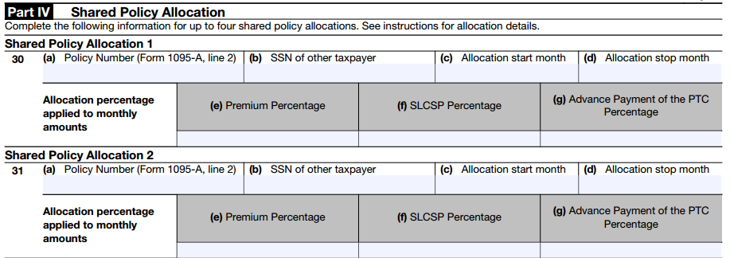

Shared policy allocation
Tax filers have a choice about how they allocate their premium tax credits. Allocation can be done in three ways:
- Agreement based—consumers can allocate any agreed percentage between themselves and the other household.
In example 3 above, if the consumer and his or her parents agree to 30/70 spilt from January through July then they would enter their respective percentages in sections (e), (f), and (g) and include the SSN of the primary tax filer on the other household in section (b) and the allocation months in sections (c) and (d) of their individual 8962 forms.

- 100% allocation—both parties can agree to allocate 100% to one person/household.
In example 2 above, if the consumer and his or her parents agree on 100% allocation to the parents then the parents would enter “100” and the consumer would enter “0” in sections (e),(f), and (g). Both households would complete the other required sections as described above.

- Non-agreement based—if an agreement cannot be reached, 50% has to be allocated to each of the households.
In example 1 above, if the consumers (former spouses) do not have an agreement on the amount to be allocated to each household then they would both have to enter 50% and other required information as described above.
For more information on shared policy allocations, please refer to Form 8962 Instructions.

